Floodwater may contaminate any fruit, vegetables or herbs that you have growing in your garden.
Don’t eat any produce that is grown directly in the soil and has come into contact with floodwater.
Throw out leafy greens such as lettuce, spinach, and Asian vegetables like pak choy, as well as berries and herbs. These are highly likely to have bacterial contamination and are not practical to clean.
You can clean:
- beans, tomatoes and capsicums
- carrots and potatoes
- produce with a protective outer skin such as peas, melons, corn or oranges
You must soak them in 2 tablespoons of household bleach (4 to 6% chlorine) per 4 litres of water. Before eating, peel and cook them (if possible).
After flooding, your garden will take about a month to become clean. You should avoid planting any vegetables, fruit and herbs during this time.

Mosquitoes
Floods also lead to an increase in mosquito breeding sites and activity.
To reduce mosquito’s breeding on your property:
- empty containers where rain or floodwater has collected - including pot plants, tarpaulins, palm fronds, buckets, tin cans, and roof gutters
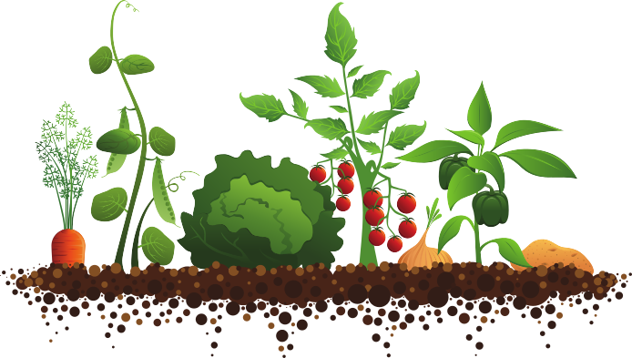
- check mosquito screens and flip valves on rainwater tanks to ensure they’re still intact and working correctly.

