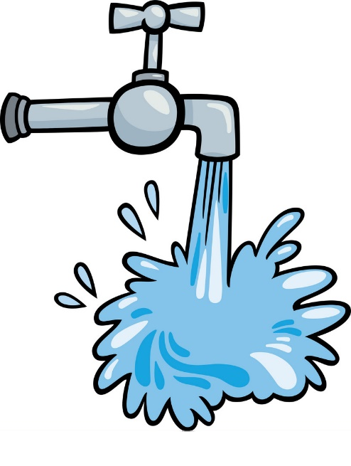
If your area has been affected by flooding, your tap water may not be working or safe to drink.
To disinfect your water, follow these steps:
Step 1. Strain the water through a clean cloth to remove dirt, debris or mud.
Step 2. Boil the water for at least one minute and let it cool before:
- drinking
- cleaning your teeth
- preparing food.
Step 3. Repeat step 1 and 2 until NT Health have advise your tap water is safe to drink.
If your tap water is not working, other sources of water can be found in your hot water system or rainwater. Before drinking the water, disinfect it by following the steps above.
But if the water has an unusual odour or colour, or may be contaminated with chemicals, do not drink or use it. Boiling it will not remove chemicals.
If there is shortage of safe-drinking water, don’t use it for other purposes. This includes bathing, washing clothes, dishes or flushing toilets. Untreated water from swimming pools or rainwater should be used instead.

