It is important to wash and disinfect every part of your home that has been covered by floodwaters.
Make sure you follow any specific clean-up advice or processes.
In most cases, household cleaning products will be sufficient. Always check the label for directions.
You should:
- tackle cleaning one room at a time
- make sure you’re working in a well-ventilated area, particularly when using chemicals
- treat all items as contaminated and wash your hands with a disinfectant soap after handling them
- wear protective clothing that limits contact with the skin.

Floors and walls
Wash out mud and debris using a hose at medium pressure.
Clean your surfaces using 2 buckets - one filled with water and the other with soap and water.
Rinse your sponge or mop in the first bucket, keeping most of the dirty rinse out of your cleaning solution.
After a day or 2, you may need to go over rooms or objects again.
Use a disinfectant or a solution consisting of half a cup of household bleach (4 to 6% chlorine) to 5 litres of water. This will kill germs, mould, fungi and mildew.

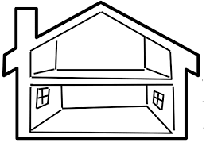
House
It will take several weeks to completely dry out your house.
On dry days, keep all doors and windows open.
If your heaters are safe to use, turn them on, leaving the windows open.
Ignore mould growing on wet linings until drying is complete. It can then be removed.

Food
Throw out all foods exposed to floodwater.
Foods in sealed cans can be kept if you follow these steps:
Step 1. Remove the paper labels.
Step 2. Write on the cans with a permanent marker so you can tell what's in them.
Step 3. Disinfect steel cans in a solution of 3-quarters of a cup of household bleach per 5 litres of water for 2 minutes.
Do not treat aluminium cans.
Step 4. Rinse the cans in clean water.

Kitchen items
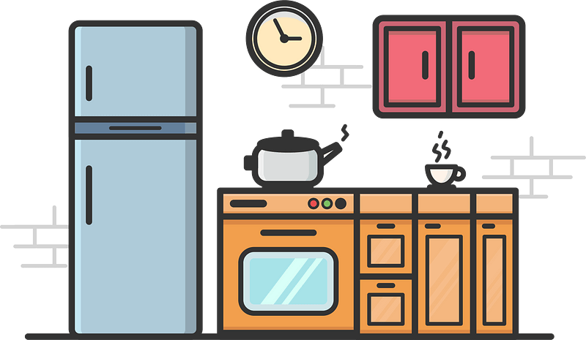
Disinfect your dishes and glassware in a solution of one tablespoon of household bleach (between 4 to 6% available chlorine) per 5 litres of warm water.
Alternatively, you can run them through the dishwasher on the hottest setting.
Only use your dishwasher once your water is safe to drink and your sewer lines work. Clean and disinfect your dishwasher first.
Items like wooden spoons and chopping boards, and plastic and rubber items should be thrown out.

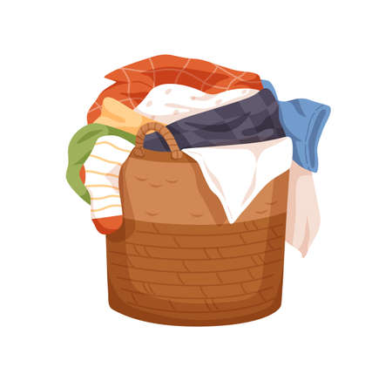
Clothing and linen
Throw out damaged bedding and pillows. Feather and foam rubber pillows can be washed.
Brush dirt off fabric items then rinse thoroughly in cool water to remove mud. Dry in the sun to remove odours.
Rinse leather and suede jackets in cold water. Dry leather away from heat and sun.
Clean your washing machine by running it on empty for a 15-minute cycle with hot water and disinfectant.

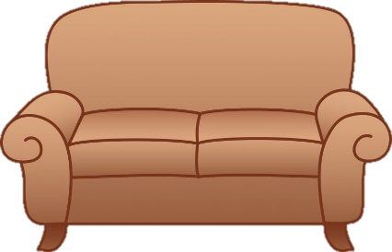
Furniture
When it’s not raining, take all furniture outdoors, but keep it out of direct sunlight to prevent warping or fading.
Scrub mildew from wood furniture using 4 to 6 tablespoons of baking soda per 5 litres of water. Rinse with clean water and dry.

Valuable books and papers
Separate the sheets of paper as soon as you can and allow them to dry. Do not try to unfold wet paper because it tears easily.
Small bundles of paper from filing cabinets can be placed in a freezer to stop mould and deterioration. When time allows, bundles can thaw and sheets can be separated and dried.
Place books to dry and keep the pages apart. After airing, pile and press them to keep the pages from crumpling.

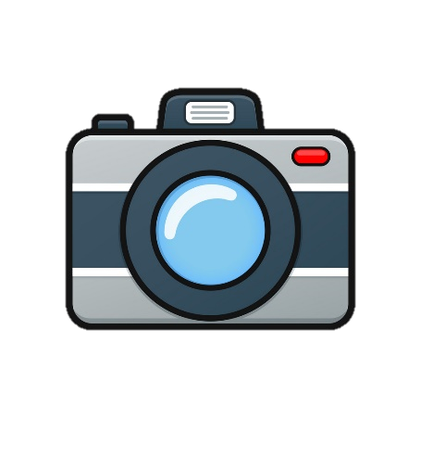
Photos
Do not let your photos dry out, as they will stick together and will be impossible to separate.
If you cannot work on them in the first 48 hours, stack the wet photos between sheets of wax paper and freeze them in a sealed plastic bag. When you have time to do it properly, you can defrost, separate and air dry them later.
You can separate wet or frozen photographs in a tub of cold, clear water. Do not wipe the wet front of the photographs. Lay the images face up to dry.

Hot-water systems
A qualified repair person should only repair a flooded hot-water system.
It may operate okay for a while, but hidden corrosion damage may make it stop working safely.

