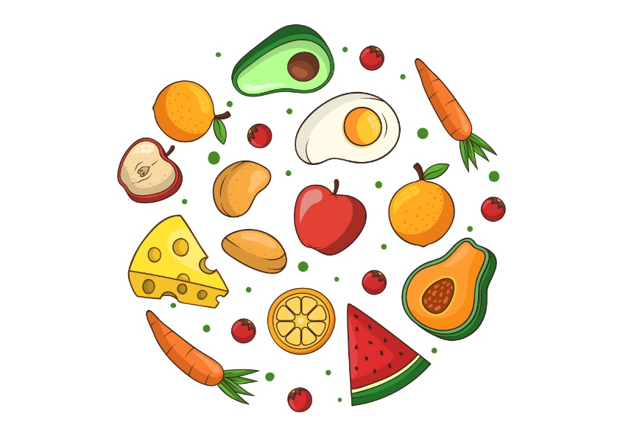
Some foods that have not been kept under temperature control for some time may not be safe to eat.
This may include:
- cooked meats
- dairy products
- cooked pasta and rice
- cooked meals with meat, fish or eggs
- prepared salads
- vegetables and fruit
- seafood.
They must be thrown out - if it hasn’t been done already.
The basic rule is ‘if in doubt, throw it out’.

