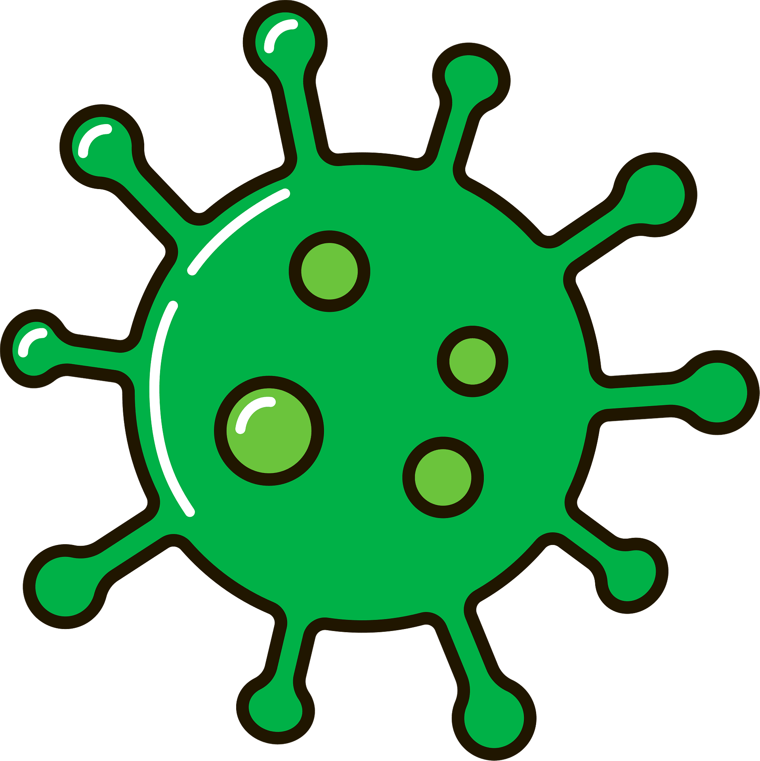
Floodwaters contaminated with sewage may carry germs that can cause disease or infections.
You’re most at risk when you expose cuts or abrasions to contaminated floodwater.
To help prevent infection, follow these guidelines:
- treat all floodwater as contaminated
- wash your hands thoroughly with soap and water after:
  - contact with floodwater, mud and flood-affected items
  - cleaning up
  - going to the toilet
  - before eating food
- avoid cut or abrasion contact with floodwater or contaminated materials
- treat all cuts and abrasions with antiseptic and cover immediately
- keep children away from mud and floodwaters
- wear protective shoes if you’re going to be in contact with mud and floodwaters
- wear gloves when handling flood affected items or mud
- seek medical attention if you have wounds that are deep, red or swollen - check your tetanus vaccination status.
If you or your family have severe vomiting or diarrhoea, seek medical attention.
You will require extra fluids of electrolytes and sugars, such as Gastrolyte, which can be purchased from local chemists.

Melioidosis
Melioidosis is a serious disease caused by bacteria that live in tropical soils and water.
Heavy rainfall brings them up into the surface water and soil, where they can be picked up by the wind and spread in the air.
Bacteria can enter the body through cuts and sores in your skin or through breathing in dust or droplets.
Melioidosis requires urgent medical attention as it can be fatal if not treated with the right antibiotics.

Who’s most at risk
You’re most at risk of Melioidosis if you:
- have diabetes, kidney or lung disease, or cancer
- do steroid therapy or other immunosuppressive treatment
- drink a lot of alcohol.
People with these conditions should stay indoors if possible.

Prevention
To reduce the risk of Melioidosis, you should:
- wear appropriate clothing - gloves, closed-in shoes, long pants and long sleeves shirts
- shower or wash exposed areas after cleaning up
- wear a facemask when using high-pressure hoses - this is important for those who have existing health conditions
- wash all cuts thoroughly with soap and clean water, and cover them with a bandage - if the wound is not healing or it becomes infected, seek medical advice.

Symptoms
Symptoms can develop a few days after exposure. These include fever, headaches, confusion and breathing difficulties.
If concerned about Melioidosis, contact your local clinic, GP or hospital.

Mosquito-borne diseases
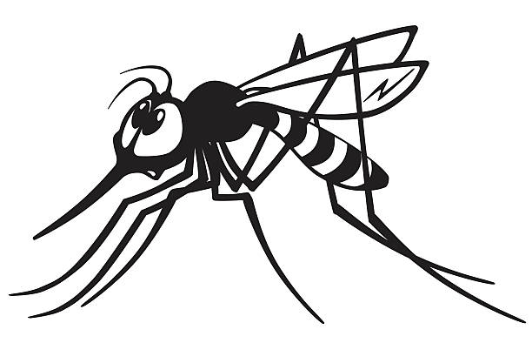
Some mosquitoes in the Northern Territory can spread diseases to humans, pets and livestock.
After heavy rainfall, mosquito activity increases and pooled water provides ideal breeding sites for them.
With large numbers of mosquitoes, you’re more at risk of getting a mosquito-borne disease.

Prevention
Protect yourself against mosquitoes by:
- staying indoors when mosquitoes are most active – 2 hours before sunset, during the night and around sunrise
- wear loose, light-coloured protective clothing when outdoors that cover your feet, legs and arms
- use insect repellents containing DEET, picaridin or oil of lemon eucalypt (PMD)
- removing potential mosquito breeding sites - store upside down or place under cover any containers that can hold water like wheelbarrows, buckets, plant drip trays and old tyres
- maintaining your swimming pool
- keeping fish ponds stocked with fish
- repairing damaged screens on rainwater and septic tanks
- ensure roof gutters are free draining.

