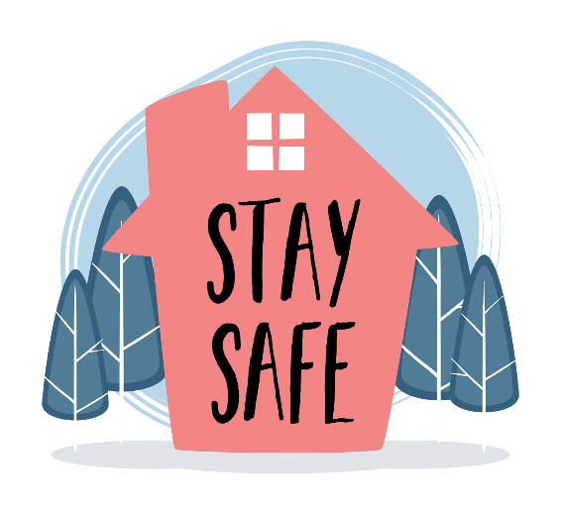
There are lots of safety factors you should consider after a flooding event.
You should consider the following guidelines:
- beware of fallen power lines, damaged trees and flooded creek
- don't drive until you know it’s safe
- look out for snakes and other animals
- do not eat food that has been in contact with floodwater - if in doubt, throw it out
- tap water may be used if the local authorities have declared it’s safe
- check your home for damage to windows, walls or roofs
- use a torch to carry out inspections inside buildings and never use matches, candles or lighters
- check your neighbours are OK
- do not use any electrical appliances which were submerged and don't handle any wet electrical equipment
- have gas appliances inspected and cleaned to prevent a gas explosion or fire
- check your smoke alarms are still working
- keep children away from floodwaters
- never go into water that is more than knee deep
- if you must enter shallow floodwaters, wear solid shoes
- stay away from drains and culverts
- avoid wading even in shallow water as it may be contaminated
- if you come into contact with water, ensure all cuts and abrasions have been cleaned, treated with antiseptic and covered immediately
- seek immediate medical attention if you have wounds that are deep, red or swollen.
- always wash your hands thoroughly with soap and clean water.

Be Crocwise
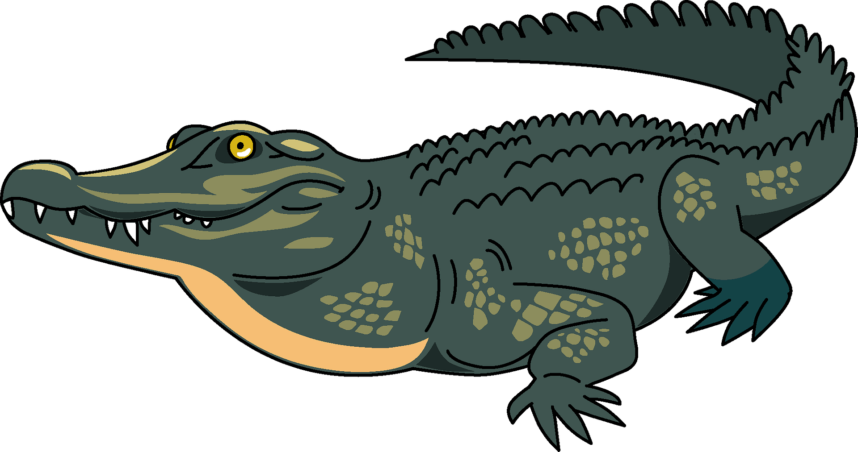
When water levels rise and flooding occurs, crocs will travel to areas where you don't usually see them.
Remember croc danger is real, so don’t risk your life.
To report croc sightings, call 0419 822 859 for the Darwin region or 0407 958 405 for the Katherine region.

